AP CSP Python with Robots  Mission 7 Obj 1-5 Assignment |  | Name:
Mission 7 Introduction
Read the introduction and project goals. During this assignment, you will complete the first three goals.
Click on proximity sensors to add it to your toolbox.
Mission 7 Objectives 1-5
Complete Objective 1. After typing the code, try CodeBot on different surfaces and measure the distance needed to detect an object. | Surface color Distance Surface color Distance  Desk edge
Start Objective 2.
What are the two optional parameters for the prox.detect() function? Explain what each one is used for:
Complete the code for Objective 2. Then use the code and CodeBot to fill in the chart. First use the suggested power and threshold. Then experiment with your own values. Add more rows as needed.
Answers will vary. Example answers:
Power | Threshold | Surface Color | Detection Distance
4 | 25 | Desk edge
4 | 25 | Dark color
4 | 25 | Light or white color
4 | 50 | Desk edge
4 | 50 | Dark color
4 | 50 | Light or white color
4 | 100 | Desk edge
4 | 100 | Dark color
4 | 100 | Light or white color

Complete Objective 3. If you want to slow down the printing on the console panel, you can import sleep and use a delay. | 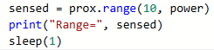
Complete Objective 4. Follow CodeTrek, but create a cal_thresh() function for all the code inside the button press. You will need to add a global statement inside the function.  In the main program, you can delete all the code below leds.prox(p) since it is now in the function. | Start of function definition:  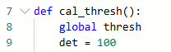  Main program:  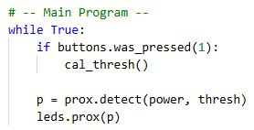
Complete Objective 5. Follow CodeTrek to modify the function.
Take the Quiz.
How did you do? Are there any concepts or specific topics you need to review?
After Objective 5 and the Quiz, turn in this assignment.

